



Ref. Ares(2016)5658895 - 29/09/2016

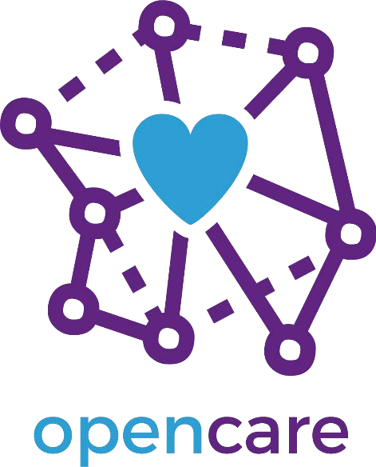

# Deliverable 1.1: Hackathon documentation

|  |  |  |
| --- | --- | --- |
| *Project Acronym* | OPENCARE |  |
| *Title* | Open Participatory Engagement in Collective Awareness for REdesign of Care services | |
| *Project Number* | 688670 |  |
| *Work package* | WP1 – Learn, engage and disseminate | |
| *Lead Beneficiary* | SCImPULSE Foundation | |
| *Editor(s)* | Guy Melançon | *University of Bordeaux* |
| *Reviewer(s)* | Alberto Cottica | *Edgeryders* |
| *Dissemination Level* | Public |  |
| *Contractual Delivery Date* | 30/09/2016 |  |
| *Actual Delivery Date* | 30/09/2016 |  |
| *Version* | 1.0 |  |
| *Status* | Completed |  |

Summary

D1.1 Hackathon documentation 3

Masters of Networks 4 (MoN) 3

Stockholm participatory design session 6

Conclusion 8

# D1.1 Hackathon documentation

This document is a companion to the deliverable D1.1 : Hackathon documentation*: Documentation for multidisciplinary, open to the public, hackathons.

Prepared ahead of time documentation, as well as follow-up documentation to optimize and support collective engagement and common vision of the community’s activity. (Delivery dates: 1st edition month 3, 2nd edition month 9.)

(Excerpt from DoA, WP1 - Learn, engage and disseminate led by SCImPULSE)

The deliverable itself actually corresponds to material available on the edgeryders platform: <https://edgeryders.eu/en/op3ncare/home> (more specific URLs are provided in later sections).

The material was used during live sessions that took place on the occasion of two events gathering consortium partners, also including other non-consortium participants.

* Masters of Networks 4 in Brussels on February 27, 2016
* Participatory design workshop held in Stockholm on June, 20th to 22nd, 2016

The material used was developed in synergy with comments, requests and remarks from users who engaged in the design of the sessions. Links to all material will be provided within this companion document.

The workshop implicitly intended at developing a common vision on how socio- semantic social network visualization and analysis can be leveraged in the context of the opencare project (seen as part of Task 1.1 objectives).

# Masters of Networks 4 (MoN)

**Masters of Networks 4** was part of the LOTE5† event in Brussels, on February 27, 2016 hosting the consortium first meeting (kick-off).

Preparation of the MoN hackathon sessions took place as wikis, events and/or discussion threads on the edgeryders.eu platform‡. The workshop format and full history of preparatory discussions is accessible here:

*Getting ready, engaging people:*

https://edgeryders.eu/en/lote5/masters-of-network-4-networks-of-care

* This deliverable relates to Task 1.2 (Sharing knowledge for better consortium interoperability) aiming at engaging all partners to develop a common, multi- disciplinary vision of the community’s activity.

† See https://edgeryders.eu/en/lote5

‡ See https://edgeryders.eu/en/lote5/masters-of-network-4-networks-of-care

Visio calls were also organized (some links still visible on the wiki).

Several ideas were proposed to motivate the use of socio-semantic social networks.

* The use of data on Wikipedia page visits (pages related to care, part of the ) was considered as a possible direction to explore.
* Back in February, we proposed to use data from past EdgeRyders projects recording forum discussions (posts and comments) in order to get our hands on data similar to the one we would soon be using in opencare§.
  + Ad hoc tools were designed to allow users to access opencare data**.

*Wikipedia Medicine Project*. The Wikipedia idea was later put aside since the intended use of the data turned out not to be feasible. We indeed expected to look at how Wikipedia pages on health were co-visited, in order to get a hint at how people perform self-diagnosis. However, the data made available by Wikipedia on page visits only sums up the number of visits per unit of time, and offers no information about how users hop from page to page.

The preparatory work nevertheless produced quite interesting exchanges on the how and why such an experiment could be performed. Some participants (EdgeRyders users dora and MoE) worked around the Wikipedia data during the workshop and ultimately produced visualization of this dataset.

*EdgeRyders discussion forum*. Discussion forums are a perfect fit to experiment with socio-semantic analysis since they involve users interacting with each other about specific topics. From a given standpoint, they offer a place where computer science meets with ethnography – *a fortiori* in opencare, which mobilizes ethnography to tag conversations.

At the moment of organizing MoN 4, we however did not have this type of data for opencare. We instead relied on past projects to illustrate the use of socio-semantic analysis to non-specialist participants and get their feedback on how it could be used with the opencare context.

*Massaging the data*. A variety of tools were used, with some participants already having experience with programming technologies and even with network analysis. Conversely, some participants had close to no experience in dealing with network analysis. That being said there participation was highly valued to criticize the data itself, the use of the data or the representation that were build from the data (in link with WP5).

* Tulip†† was used to produce on-the-fly visual maps of (any part) of the data during the session

§ A sample dataset is available here : https://drive.google.com/open?id=0B7HgdYQcOLwnWkQwdmY1Nm5ENGM

** See https://edgeryders.eu/en/opencare-research/waiting-for-the-dashboard-a- script-to-quantify-the

* + Tulip is open source desktop Graph Visualization framework participants were invited to install and use during the workshop. Tulip is hosted on sourceforge‡‡.
* Detangler§§ was used to explore the relationships between terms and social interactions
  + Detangler is an open source HTML5 application offering specific analytical tools for socio-semantic networks participant were invited to use during the workshop. Detangler is hosted on github***.

Various HTML5 Javascript technology were used by others to produce interactive visualizations embedded in web browsers (node.js, sigma.js)

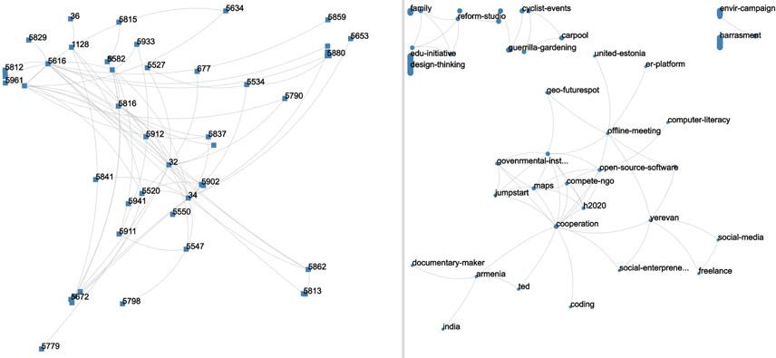

**Figure 1. Detangler view of user interaction (left) through topics (right).**

Masters of Networks 4 follow-up documentation:

https://edgeryders.eu/en/lote5-doc/documentation-masters-of-networks- networks-of-care

†† See [http://tulip.labri.fr](http://tulip.labri.fr/)

‡‡ https://sourceforge.net/projects/auber/

§§ See http://detangler.labri.fr:31497

*** https://github.com/renoust/Detangler

# Stockholm participatory design session

The second session (two half days†††) took place in a tighter context involving consortium partners only. The intent was twofold:

* to develop a common vision around the use of socio-semantic network analysis (SSNA) as a tool used in opencare (in link with Task 1.2);
* to advance towards specifications of a SSNA visual analytics dashboard, supporting the work of ethnographers (in link with Task 2.2 and Task 5.1).

The Stockholm meeting gave us the opportunity to have an active session discussing and criticizing the design of the Detangler tool, which serves as a basis for exploring socio-semantic networks.

Parallel experiments exploiting content from tweets were also discussed as an alternative material to investigate‡‡‡.

††† See https://edgeryders.eu/en/opencare-research/consortium-meeting-in- stockholm-including-travel

‡‡‡ See https://edgeryders.eu/en/opencare-research/mapping-the-opencare- ecosystem-using-twitter

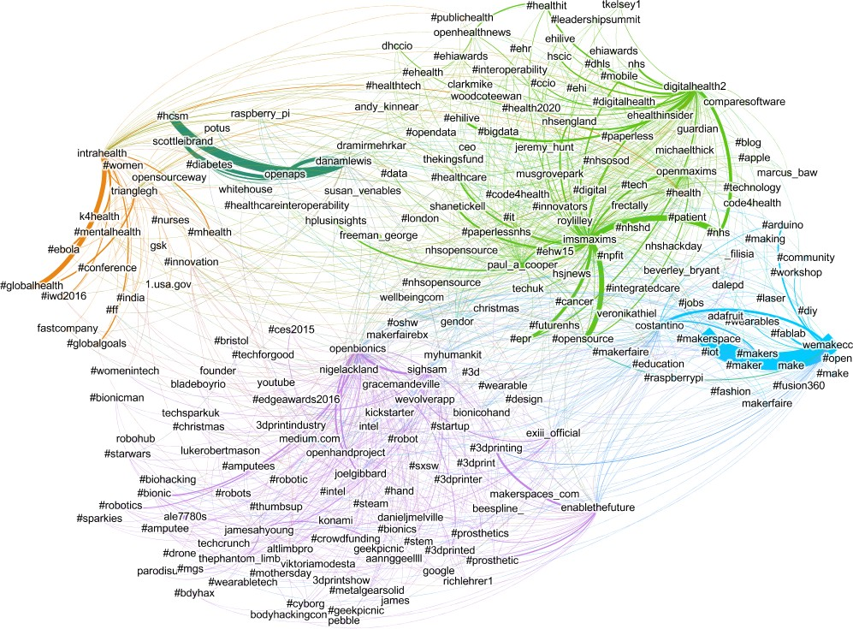

**Figure 2. Cross topic network built from tweets within the #opencare community.**

Since the socio-semantic network is ultimately built from ethnographic annotations, we further discussed how SSNA visual analytics could support ethnographic when analyzing and coding comments and posts.

In order to see how the ethnographic codes should be handled through SSNA, (technical) discussions on how ethnographic codes were stored took place on EdgeRyders portal prior to the Stockholm meeting§§§.

§§§ See

* [https://edgeryders.eu/en/open-ethnographer/fetching-openethnographer-](https://edgeryders.eu/en/open-ethnographer/fetching-openethnographer-codes-and-annotations-in) [codes-and-annotations-in](https://edgeryders.eu/en/open-ethnographer/fetching-openethnographer-codes-and-annotations-in)
* [https://edgeryders.eu/en/opencare-research/a-page-to-find-the-opencare-](https://edgeryders.eu/en/opencare-research/a-page-to-find-the-opencare-content-for-ethno-coding#comment-23543) [content-for-ethno-coding#comment-23543](https://edgeryders.eu/en/opencare-research/a-page-to-find-the-opencare-content-for-ethno-coding#comment-23543)

Discussions on the use of ethno codes started ahead from the Stockholm meeting****.

The Stockholm meeting was followed-up by several discussion on EdgeRyders portal, mainly driven by feature requests from ethnographers††††.

* The work on ethno-coding and on coupling it with a SSNA dashboard is ongoing as it relates to other tasks and other WPs.

# Conclusion

Although this deliverable was planned to be due at month T0+9, we clearly intend to continue holding SSNA workshops (most probably as Masters of Networks editions) as the project progresses, and to making them open to a wide audience.

Incidentally, Edgeryders together with UBx will participate to the Hacking Health Bordeaux event held in October 2016‡‡‡‡. The event will give us an opportunity to give a presentation. More importantly, we have posted a challenge part of the hackathon in order to collect ideas and feedback on our SSNA approach, and ultimately engage a wider crowd on that part of the opencare project.

As we make progress (mostly in WP5), datasets built from the actual discussions happening within the opencare project – and similar to those used in previous workshops – will be made available according to our data management plan. They will be used in future workshop sessions and undoubtedly become a familiar material to consortium partners if not a wider community.

**** See https://edgeryders.eu/en/open-ethnographer/oe-still-on-track-taking- advantage-of-opencare-h2020

†††† See https://edgeryders.eu/en/open-ethnographer/voip-call-on-the-next-steps- for-openethnographer

‡‡‡‡ See <http://hackinghealth.ca/fr/event/hhbordeaux-fr/>